

Content:

Details:

1. Introduction
2. Step by step guidelines
3. Conclusion
4. Index

Pages:

3

4

9

10

Introduction:

The music rating application is implemented and designed to collect and store music records. It is also designed to delete unwanted records and update and search for current ones. You, as the user, must decide on what kind of information you would like to render for your music. Already, varies of music application have been developed and produced but, what makes this one so distinguishable from others? Giving you guidance, there are steps you must follow to understand how certain functions operate.

Step by step Guidelines:

1.

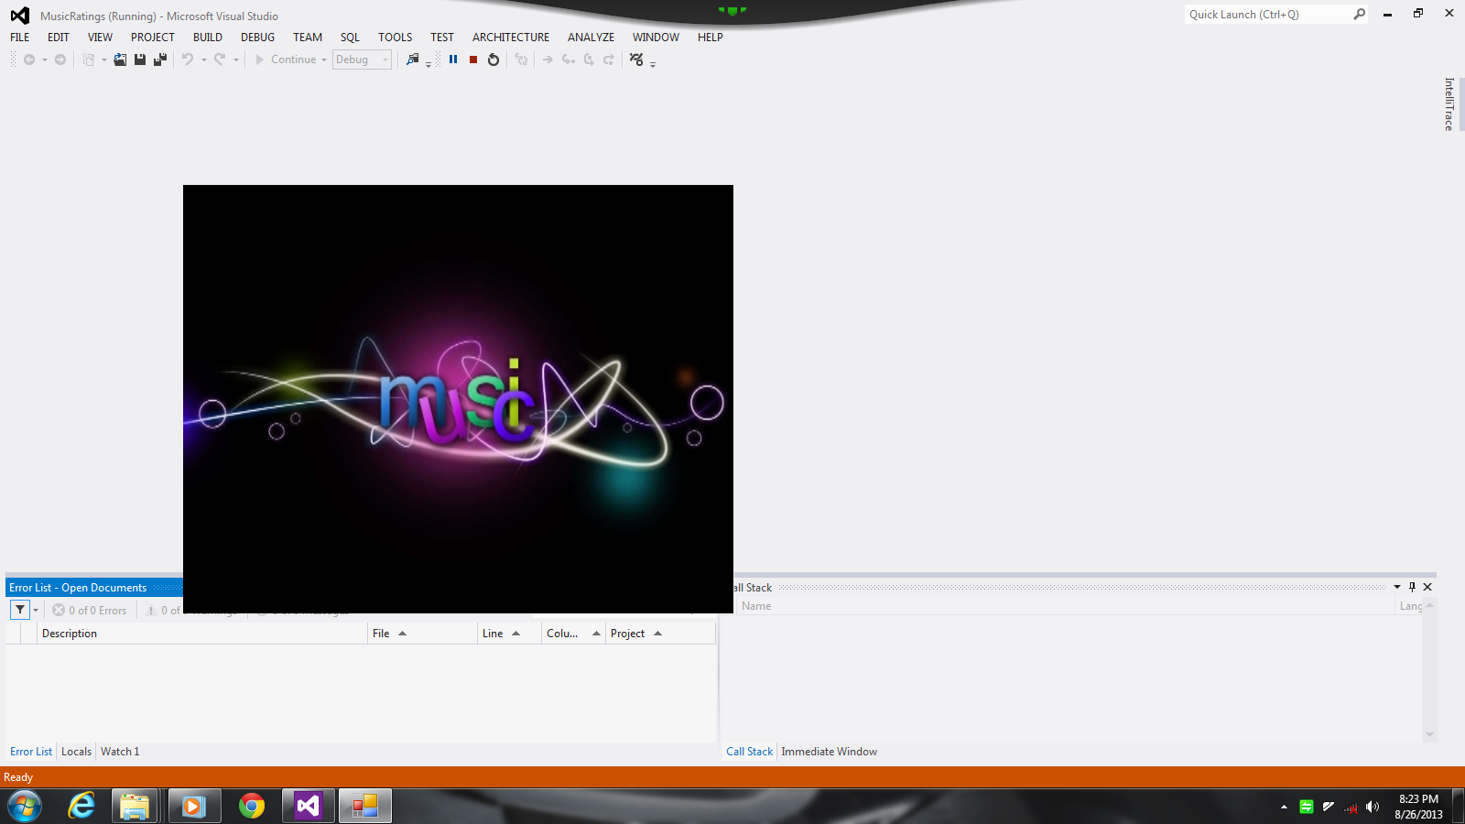

2.

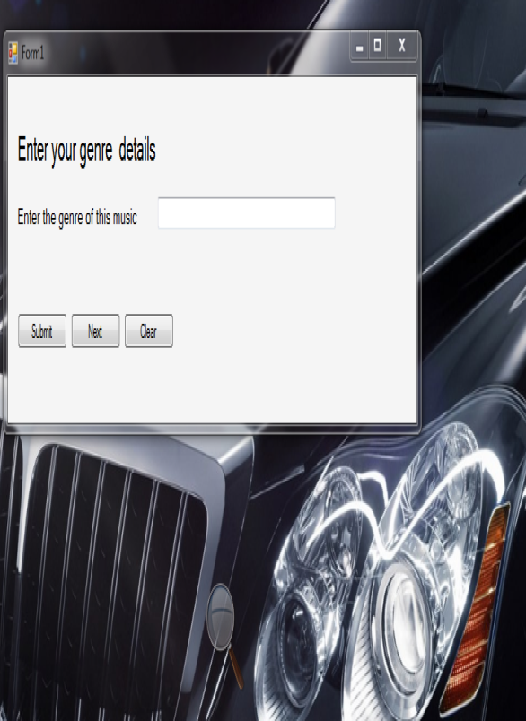

Splash-Screen

What appears first in the application is the splash-screen. This form will be displayed for approximately three seconds as it is being initialized. After it has closed, a second form appears.

Adding the genre

1. The genre textbox: You enter in the genre of your music before saving it.

2. The clear button: clears the genre textbox, if necessary.

3. The next button: Advance to a new form.

4. The submit button: Add or stores the name of your artist to your music collection.

3.

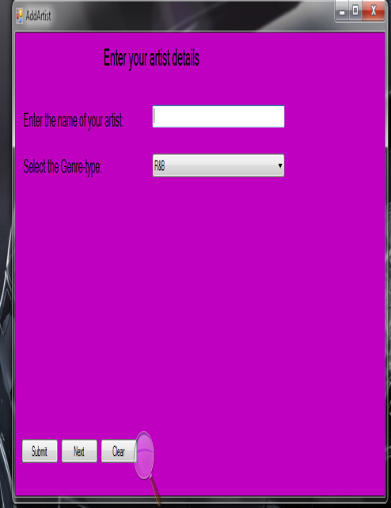

4.

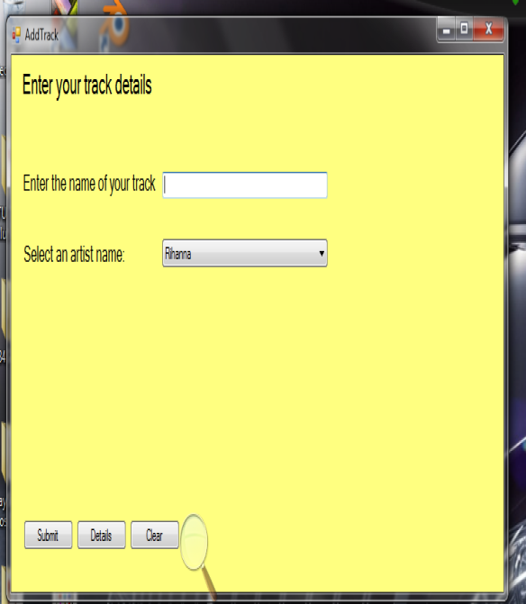

Adding the name of the artist

1. The artist textbox: You enter in the name of your artist before saving it.

2. The Genre combo-box: You select the type of genre for your artist.

3. The clear button: clears the artist textbox, if necessary.

4. The next button: Advance to a new form.

5. The submit button: Adds or stores the name of your artist to your music collection.

Adding the name of the track

1. The track textbox: You enter in the name of your track before saving it.

2. The artist combo-box: You select the name of your artist for your track.

3. The clear button: clears the track textbox, if necessary.

4. The next button: Advance to a new form.

5. The submit button: Adds or stores the name of your track to your music collection.

5.

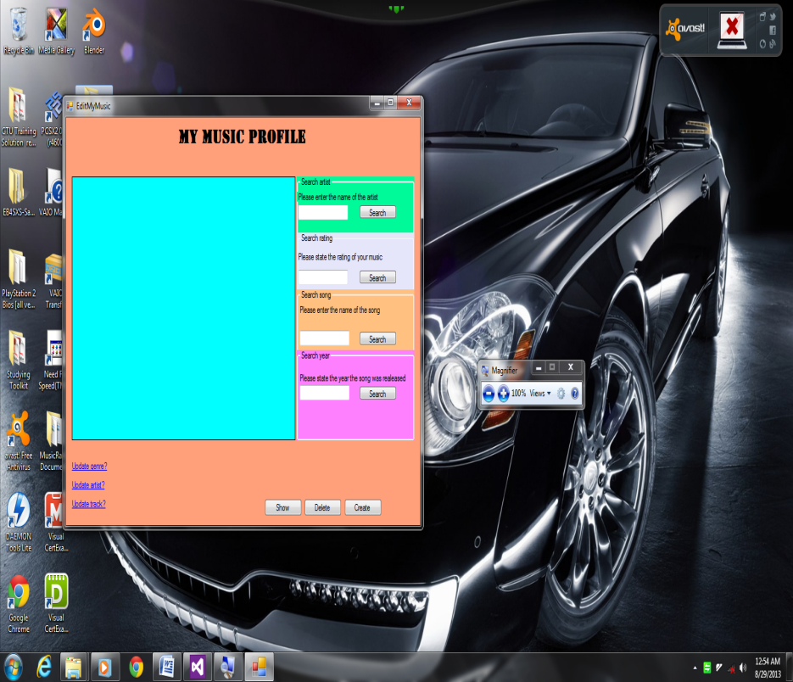

6.

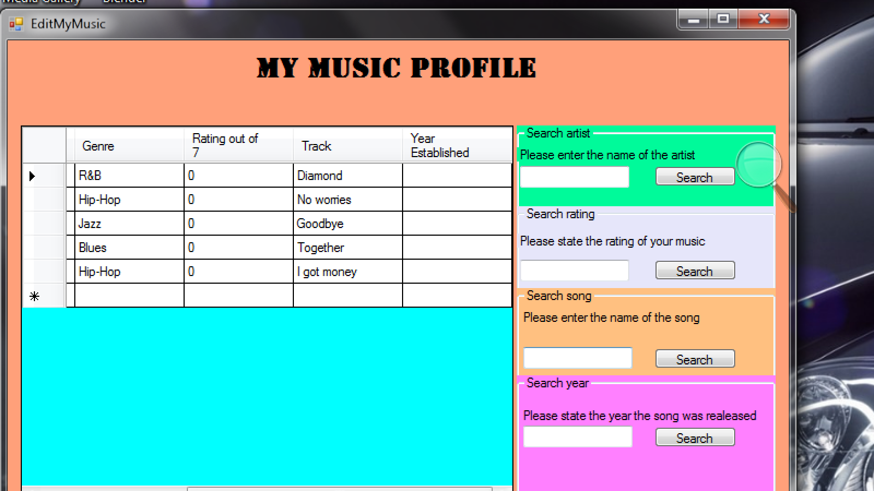

Your music storage

1. The search bars:

1. Search artist: you search the name of the artist entered in the artist textbox once you click on the artist search button.
2. Search rating: you search the rating of a music entered in the rating textbox once you click on the rating search button.
3. Search song: you search the name of the track entered in the track textbox once you click on the track search button.
4. Search year: you search the year the music was released entered in the year textbox once you click on the year search button.

2. The create button: You go back to the previous form to where you inserted your music genre, artist and track.

3. The delete button: you remove a record, displayed on the table, by selecting the whole row.

4. The show button: You display your collected music onto a table.

5. The updates link-labels:

1. Update genre: you advance to the “update genre” form.
2. Update artist: you advance to the “update artist” form.
3. Update track: you advance to the “update track” form.

6. Your music records: All your records are displayed on a table within a data-grid-view.

7.

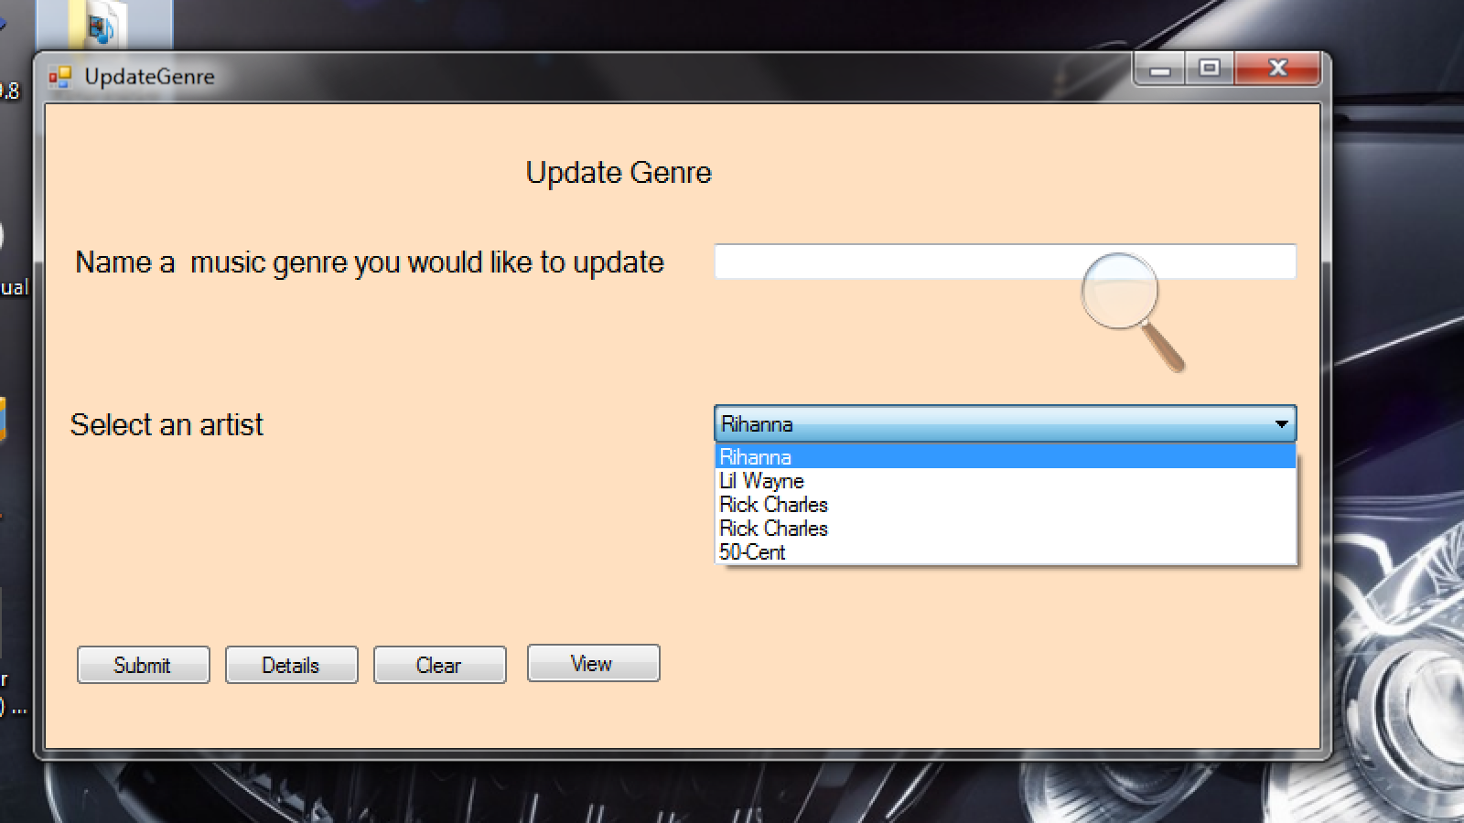

8.

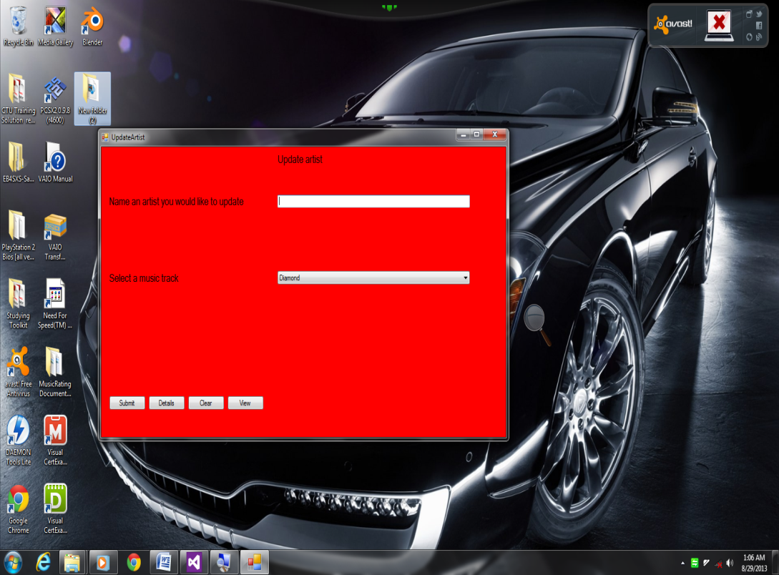

Updating the genre

1. The genre textbox: You enter in the genre of your music before updating it.

2. The artist combo-box: You select the name of your artist for your genre.

3. The view button: You display the current genre of that artist in the genre textbox.

4. The clear button: clears the genre textbox, if necessary.

5. The details button: You move back to your music storage form.

6. The submit button: Modify the genre of a particular artist to you music collection.

Updating the artist

1. The artist textbox: You enter in the name of your artist before updating it.

2. The Track combo-box: You select the name of your track for your artist.

3. The view button: You display the current artist’s name of that track in the artist textbox.

4. The clear button: clears the artist textbox, if necessary.

5. The details button: You move back to your music storage form.

6. The submit button: Modify the artist’s name of a particular track to you music collection.

9.

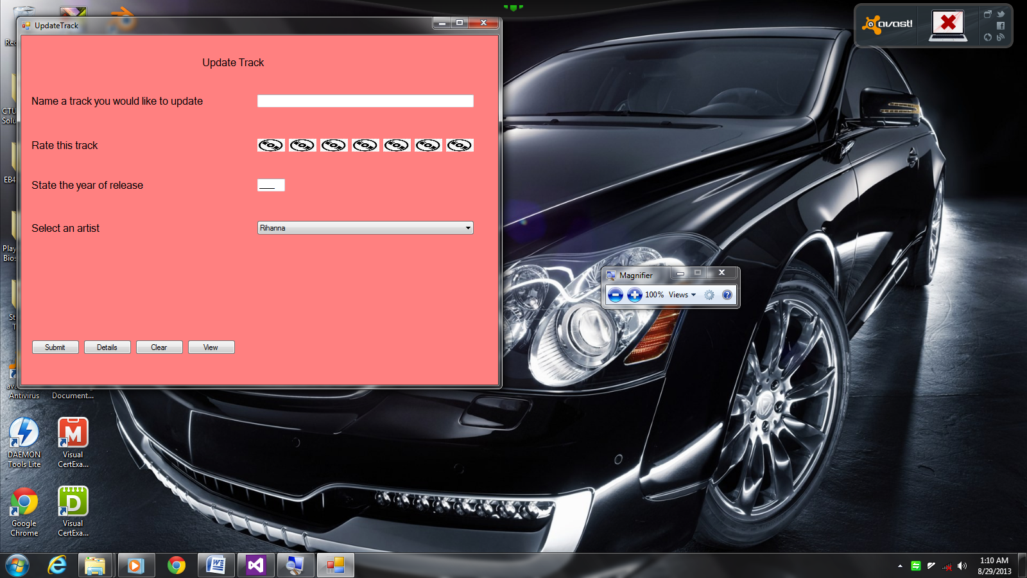

Updating the track

1. The track textbox: You enter in the name of your track before updating it.

2. Rating your track with images: Click on an image to rate your track. You will be notified on how you rated your track by a sudden change of the image(s).

3. The year established textbox: You enter in the year the track was released before updating it.

4. The artist combo-box: You select the name of your artist for your track.

5. The view button: You display the current track’s name, the rate and the year released of that artist in the track textbox.

6. The clear button: clears the artist and year textbox and sets the rating images to default.

7. The details button: You move back to your music storage form.

8. The submit button: Modify the track’s name, the rating and the year established of a particular artist to you music collection.

Conclusion

The music rating application can be utilized and influenced by certain types of audiences: adolescents, entrepreneurs, musicians and parents. It is declared to be “user-friendly” due to confining users from initializing data outside the boundary, for example; the year the music was established is entered in numbers rather than in words. With full guarantee, users will enjoy using this application and they will also linger to perpetually collect and store their favorite music.

Index

Details:

1. Deleting
2. Inserting
   * 1. Genre
     2. Artist
     3. Track
3. Music profile
4. Search
5. Splash-screen
6. Updating
   * 1. Genre
     2. Artist
     3. Track

Page:

6

4

4

5

5

6

6

4

7

7

8

9